**Assignment – 1**

**Visualization of Startup Datasets.**

**Team ID: PNT2022TMID06631**

**Roll No: 61071911138**

**Challenge:**

Upload the dataset to Cognos Analytics, explore and visualize the dataset.

**About the dataset:**

This particular dataset holds data from 50 start-ups in New York, California, and Florida. The features in this dataset are R&D spending, Administration Spending, Marketing Spending, and location features, while the target variable is: Profit.

1. **R&D spending**: The amount which start-ups are spending on Research and development.
2. **Administration spending**: The amount which start-ups are spending on the admin panel.
3. **Marketing spending**: The amount which start-ups are spending on marketing strategies.
4. **State**: To which state that particular start-up belongs.
5. **Profit**: How much profit that particular start-up is making.

**Data visualization and exploration:**

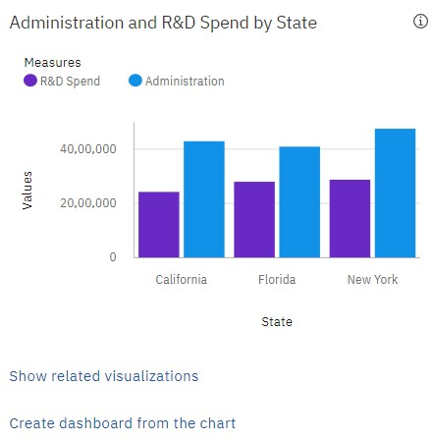

Here we can find that every start-up a huge amount of amount in administration, and more than 50% of administration amount on R & D. Its usual that all the organization spend most of the amount on administration.

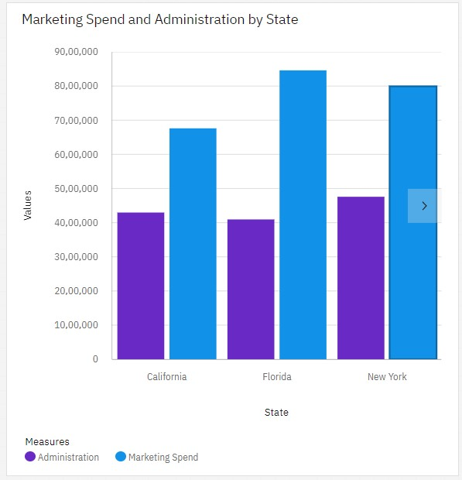

From this we understand that start-ups are spending money on marketing their products basically more than administration. Almost start-ups from all province focus on marketing. Comparatively start-ups from Florida spend a lot on marketing and start-ups from California focus less on marketing when compare to other provinces.

**Profit based analysis:**

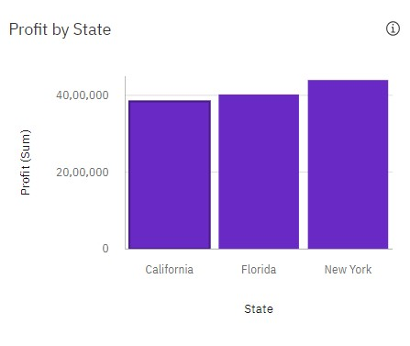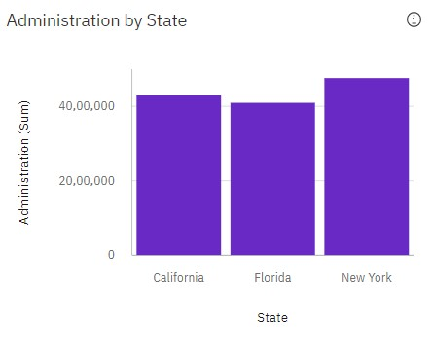

Obviously, the state which has more no of start-ups, generate the more no of profit. But when you compare these two charts, we can clearly understand case of Florida and California is different. Here Florida have comparatively less no of start-ups than California. But the profit generated in Florida is higher than California. This shows that efficiency of startups in Florida is something bigger.

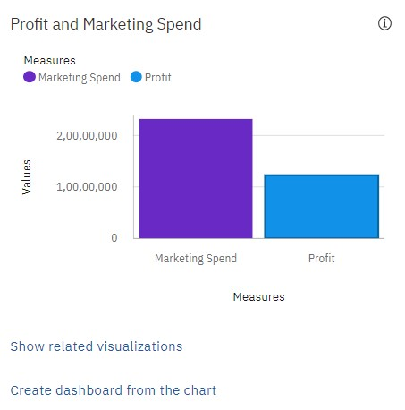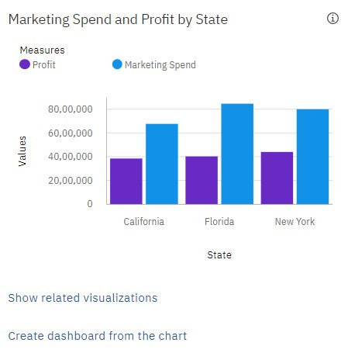

Overall, all start-ups in every state spend a huge no of amount in Marketing, but the reflection of marketing in companies profit generation is half of its total value. The exceptional Case is California, where the ratio of amount spend in marketing and profit generation is higher than the other two provinces. Its really hard to attract people in Florida via Marketing.

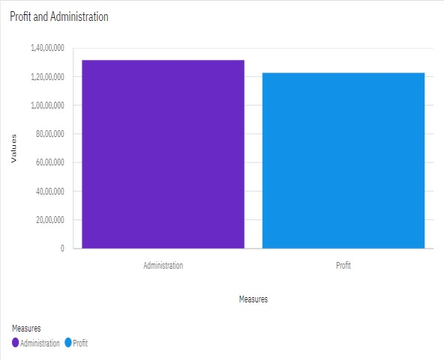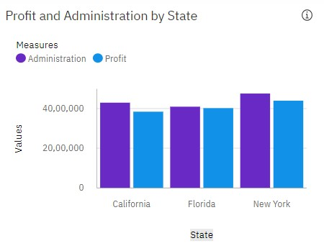

Ultimately, the profit generation depends on few factors like administration, marketing, r&d. It reflects that how much we spend on administration to make it better will make the result of profit generation better. These charts show that how much we spend on administration will return back as profit.

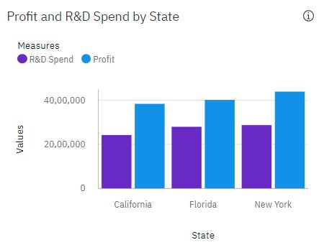

The money start-ups invest in r&d is complete worth that it is generating profit more than the amount invest on r&d.

**Overall analysis of Profit:**

We clearly understand that profit is combination of returns bring back by the administration, marketing and r&d. But this analysis shows that start-ups will generate a more profit when they split the portion of amount spend on marketing and put it in administration and r&d. These two factors play a major role on organizations profit.